Electronics: ECE 3355
Homework 2

This homework assignment includes problems from the textbook, and from this document. Please do all the problems, and submit them.
Sedra and Smith, 8th Ed., Chapter 1: Problems 1.48, 1.49, 1.53, D1.55, 1.60
From handout below: Problems E2.1, E2.2, E2.3, E2.4

E2.1. A compact disc (CD) player laser pick-up provides a signal output of 10[mV]pp and has an output resistance of 10[kΩ]. The pick-up is to be connected to a speaker whose equivalent resistance is 8[Ω].
- Calculate the voltage that would be delivered to the speaker if the speaker were connected directly to the pick-up.
- Assume that the speaker needs 20[V]pp to deliver clear acoustical output. Design an equivalent circuit for an amplifier that would deliver this output when connected between the pick-up and the speaker.

E2.2. An amplifier has been connected as shown below, with a signal source and a load connected. In addition, a dc voltage source (V_{F}) and a resistor (R_{F}) have been attached to provide feedback. Find the input resistance seen by the signal source with the feedback in place.

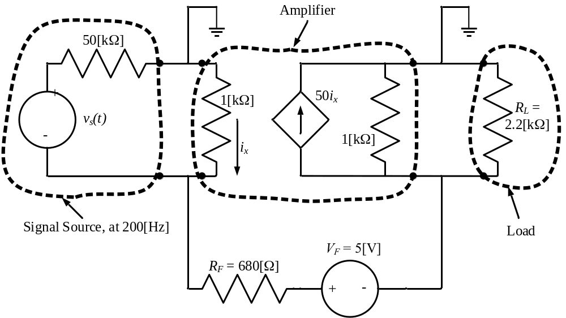

E2.3. A device, shown in Figure 3.1, can be modeled by a current source in parallel with a resistance. The relationship between the current through the device, i_{X}, and the voltage across the device, v_{X}, is given in the plot in Figure 3.2.
- Find a model for the device that would be valid when current is in the range
1[mA] < i_{X} < 5[mA]. This model must have numerical values for the current and resistance, and the polarities with respect to v_{X} and i_{X} should be shown in a diagram.
- A voltage source is applied across the device so that v_{X} = 10[V]. Find the power delivered by the device in this situation.
Remember to use lower-case variables for voltage and current.

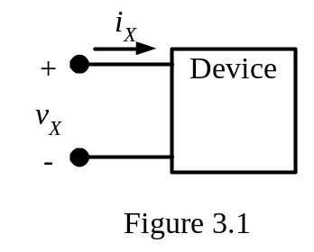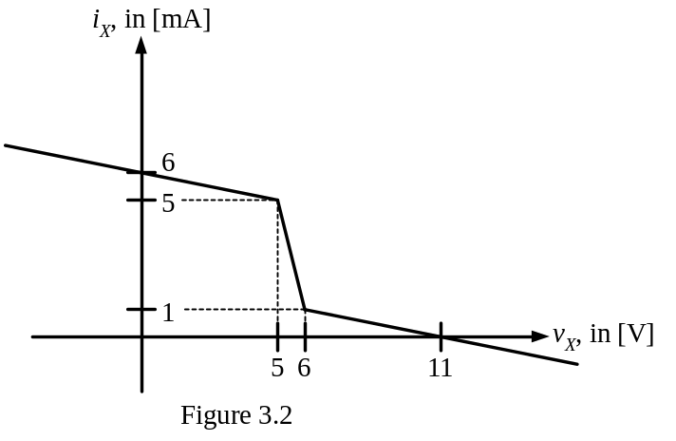

E2.4. A circuit is shown in Figure 4.1. The equivalent circuits for amplifiers A, B, and C, in this circuit are shown in Figures 4.2, 4.3, and 4.4, respectively. Find and draw a single amplifier equivalent circuit that could be used to replace amplifiers A, B, and C.

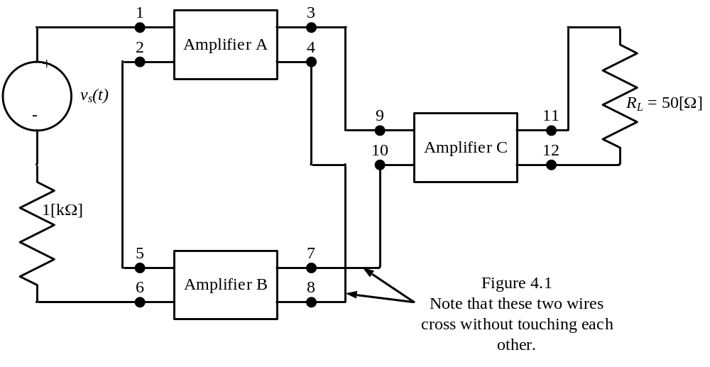
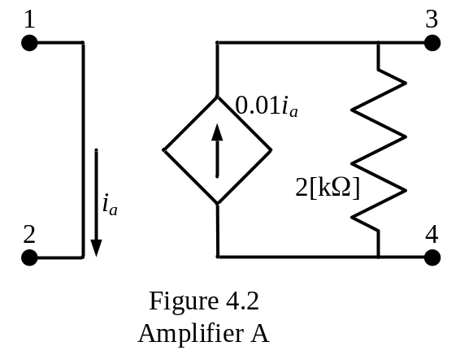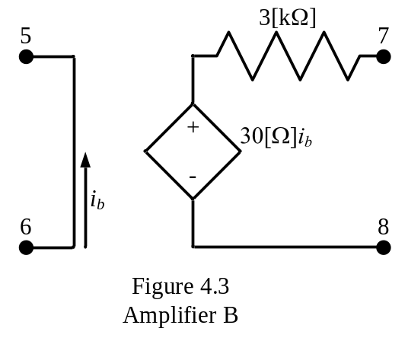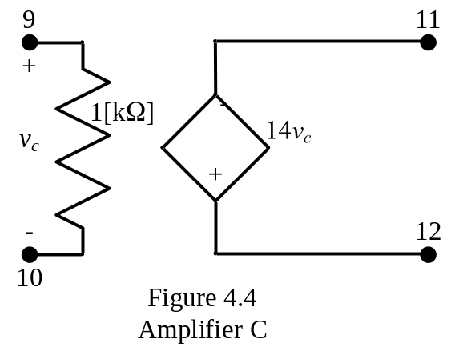

Selected Numerical Solutions: (For this homework assignment, the numerical solutions to the Sedra and Smith problems are not given.)
E2.1. There are many possible solutions. One possible solution would be a transconductance amplifier with G_{msc} = 900[S]; Ri = 10[kΩ]; Ro = 10[Ω]
E2.2. –43[Ω]
E2.3. a) The solution is a Norton equivalent. The sign of the current source depends on the reference polarity chosen, but the magnitude is 25[mA]. The resistance is –250[Ω].
b) p_{DEL,DEV} = -2[mW].

E2.4. Transresistance amplifier, with R_{IN} = 0, R_{OUT} = 0, and R_{MOC} = -117[Ω].

